Practical No: 1-A
Title: Kotlin Demonstration
1A] code: positive or negative
fun main(){
val number = -10
if(number > 0)
{
print("POSITIVE NUMBER")
}
else{
print("NEGATIVE NUMBER.")
}
}
output:
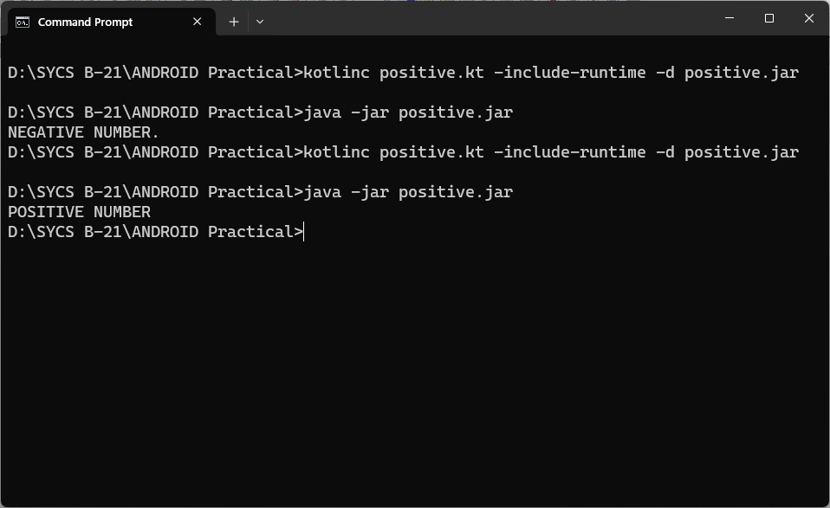
1b] code: even odd
fun main(){
val number = 21
if(number %2==0)
{
print("EVEN NUMBER")
}
else{
print("ODD NUMBER.")
}
output:
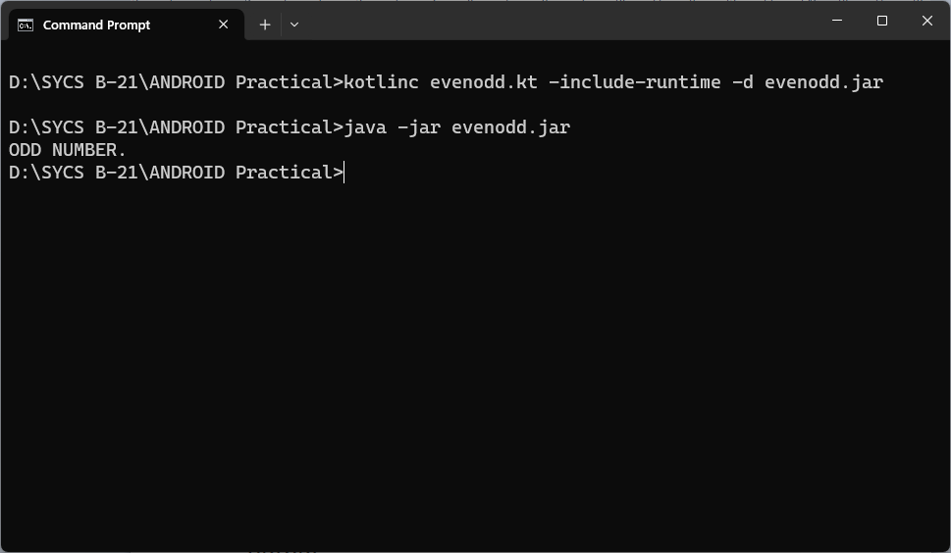
1c] code: max value
fun main(){
val a = -9
val b = -11
val max = if(a>b){
println("$a is larger than $b")
println("Max variable holds value of a.")
}
else{
println("$b is larger than $a")
println("Max variable holds value of b.")
}
println("max = $max")
}
output:
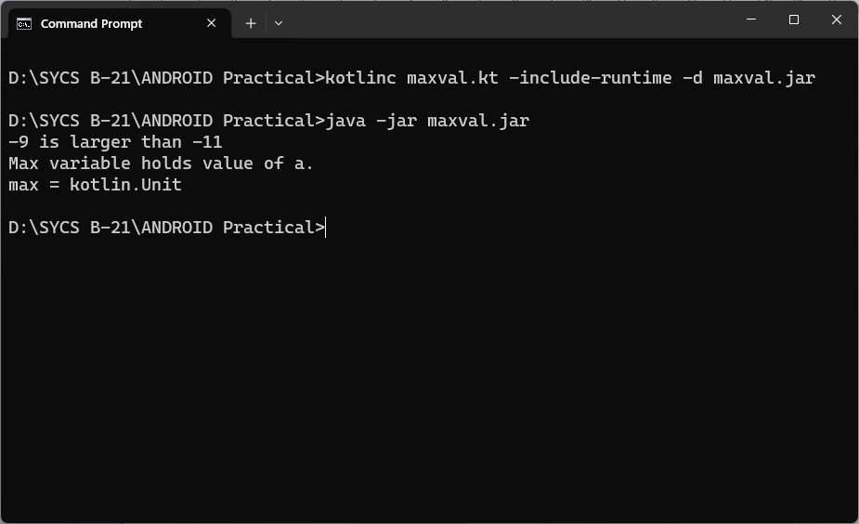
1d]code: greater value
fun main(){
val n1 = 50
val n2 = 25
val n3 = -5
val max = if(n1>n2) {
if (n1>n3)
n1
else
n3
} else{
if (n2>n3)
n2
else
n3
}
println("max = $max")
}
output:
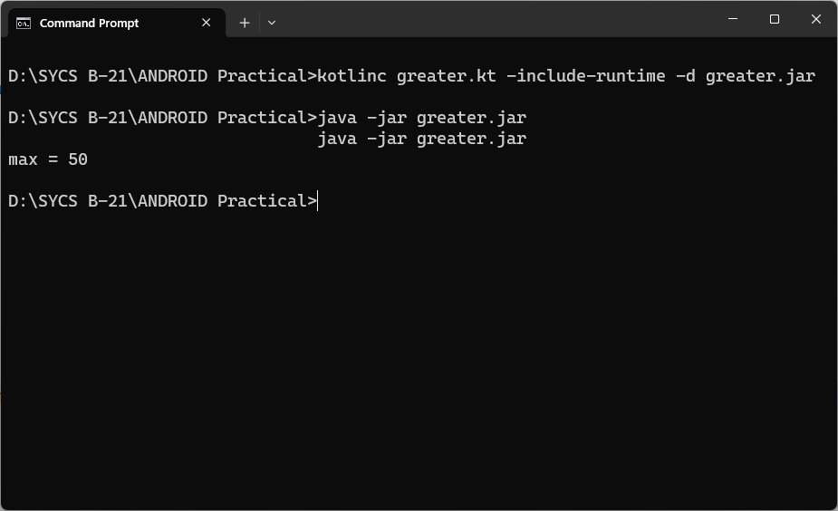
1e] code: to check days
fun main(){
val day = 4
val result = when(day){
1->"Monday"
2->"Tueday"
3->"Wednesday"
4->"Thursday"
5->"Friday"
6->"Satday"
7->"Sunday"
else->"Invalid Day."
}
println(result)
}
output:
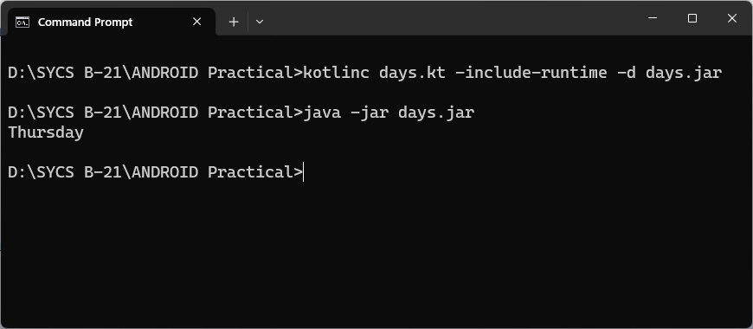
1f] code: to check operator
fun main(){
val a = 25
val b = 5
println("Enter operator either +,-,* or /")
val operator = readLine()
val result = when(operator) {
"+" -> a+b
"-" -> a-b
"*" -> a*b
"/" -> a/b
else -> "$operator operator is an invalid operator."
}
println("result = $result")
}
output:
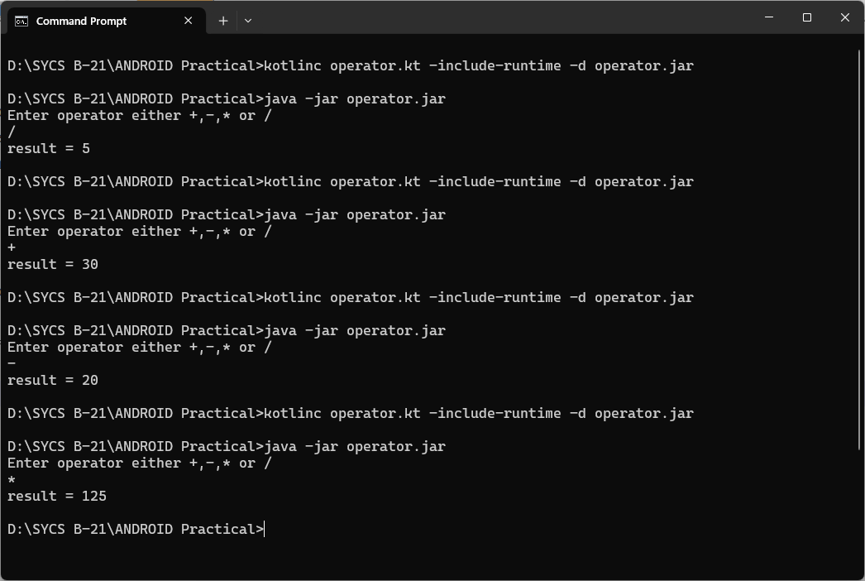
1g] demonstaration of "do-while"
code:
fun main() {
var sum: Int = 0
var input: String
do{
print("Enter an Integer: ")
input = readLine()!!
sum +=input.toInt()
} while(input!="0")
println("sum = $sum")
}
output:

